# The Beaches of Normandy

After dreaming about visiting the Beaches of Normandy for many years, I finally had the honor and the privilege to see them in person with my own eyes. The whole experience was every bit as moving as I hoped it would be . . .

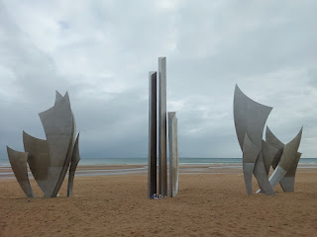

I've started reading this hefty book . . . it's gonna take me a while, but it will be worth any effort that I put in.

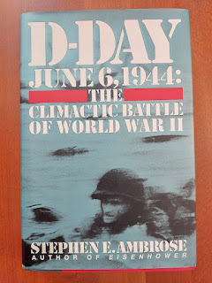

We woke up early on Saturday, June 15th, because we knew we had a big agenda for the day. First on our list: visit Omaha Beach.

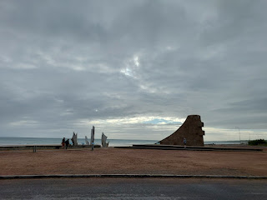

It turned out that first thing in the morning was a great time to visit the beach. We had the whole place to ourselves.

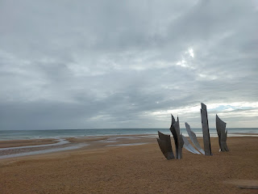

Video as we drove through one of the tiny little villages near Omaha Beach: (11 seconds)

https://photos.app.goo.gl/gtbiprE4SvdZc97A7

Video as we got closer: (19 seconds)

https://photos.app.goo.gl/KhoV2wNhYZryn2A5A

Video as we pulled into the parking lot: (8 seconds)

https://photos.app.goo.gl/bd5nMgRWybjSSoSF7

The artist who made the Omaha Beach Memorial explained the elements of his creation below: (click photo to enlarge)

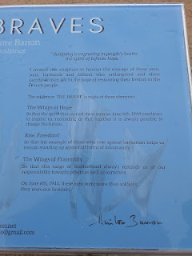

Only a few items remained after President Macron (France), Prince William, President Biden, and so many others had stood in this same place just a few days earlier . . .

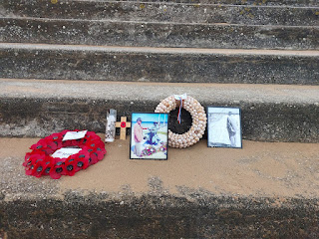



Video spanning as far as we could see in either direction: (25 seconds)

https://photos.app.goo.gl/6RcStj74Q6jsCFNe7

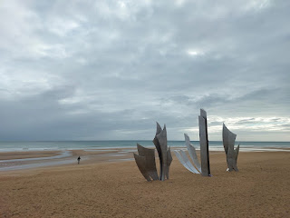

I couldn't help but stare as Scott trudged out onto the beach, all the way out to the water's edge. My thoughts turned to some of the what-ifs . . . What if he had been born a few years earlier? What if he had been sent to this very beach on D-Day? How would our lives have been forever changed?

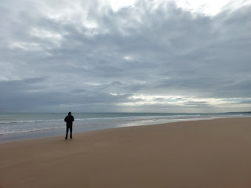

I am grateful, more than words can say, that he has had a relatively easy military career. Has it been perfect? No. Could it have been worse? Yes. Much worse. So, yes, I am grateful that he is doing well, he is healthy, he is alive, he is thriving, and he is almost done. Less than a year until his retirement . . .

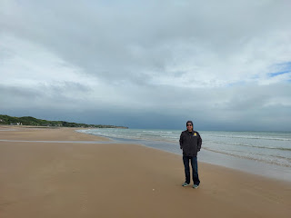

We didn't rush our experience on the beach that morning. It was so quiet . . . just us, and the sound of the crashing waves.

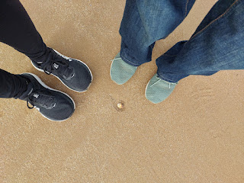

After a little while, we drove further east along the beach, until we saw this monument. We stopped to pull over and investigate. It turned out to be a monument dedicated to Charles Shay, a Native American who contributed greatly to the events in June 1944.

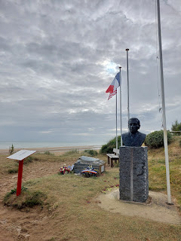

Click the photo below to enlarge and read about Charles Shay, who served as a combat medic. It was while I was reading these words out loud to Scott on the beach that I broke down and couldn't read the rest. Every skill set, every bit of effort, and every sacrifice mattered so much.

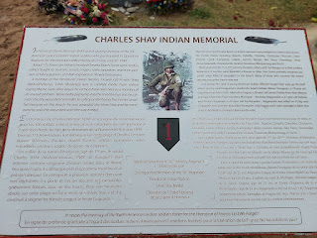

Flowers and other items, including rocks and seashells, lay at the base of the memorial for the Native American soldiers who fought here 80 years ago.

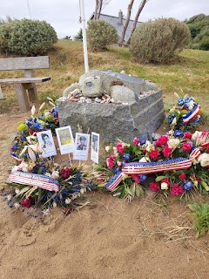

This is the spot where they fought to make their way inland . . . a small ledge above the sandy beach.

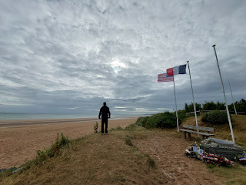

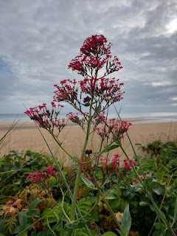

We followed a narrow walking path for a while along the edge of Omaha Beach. We trudged along in silence for the most part, trying to be mindful of the sacrifices - as well as the successes - that happened here in 1944.

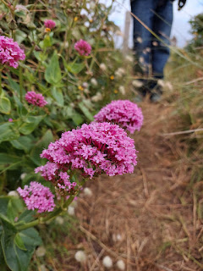

It felt odd to me that houses have been constructed so close to Omaha Beach. It almost felt offensive to me. After all, this was hallowed ground. But Scott didn't share my same feelings. He didn't think the houses did anything to detract from what had happened here before. Maybe I'm just more sentimental, I guess.

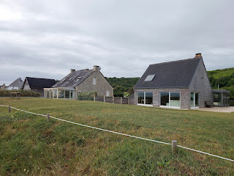

This homeowner took an interesting approach to sprucing up their back yard . . . by placing a park bench on top of what used to be a German bunker.

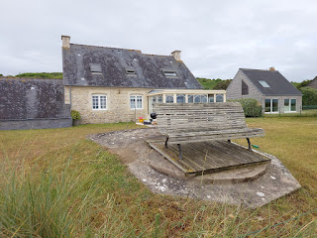

We drove a little further east on Omaha Beach, where there was another memorial and bunker on top of a large hill.

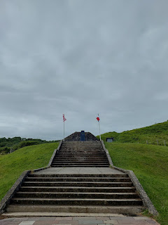

A memorial for those who served in the Second Infantry Division . . .

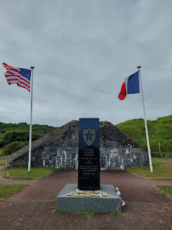

Photos of some of the men who served in this unit . . .

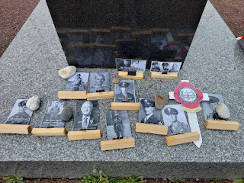

A description of what happened in this very spot 80 years ago: including the first road that was cleared to allow inland access. (click photo to enlarge)

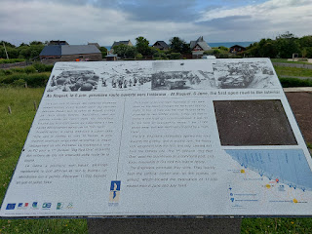

Video of Scott going inside the bunker to take a look: (5 seconds)

https://photos.app.goo.gl/RufUfJtT7gpmynXh8

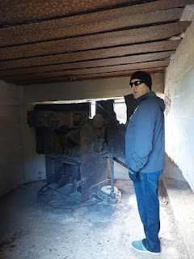

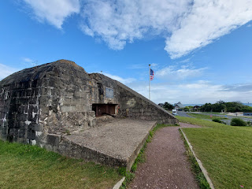

We walked up the secondary hill behind the bunker. There was a steep little trail that led up to where 30-ish sheep were grazing, and we could hear a farmer plowing the field on the other side. As we tried to approach the sheepies, they were quite shy and afraid and went trotting off in the opposite direction.

On the trail, there was another marker, this time for Bernard Dargols. Since the wording is a little small, I'll transcribe it for you.

"Born in Paris, Bernard Dargols traveled to the US in 1938 to study. In June 1940, at the age of 20, he decided to join the US Army. In 1943, he became a US citizen and started his GI training. In June 1944, he joined the MIS (Military Intelligence Service) and on June 5th 1944, he sailed from Cardiff (Wales) and landed at Easy Red Sector on Omaha Beach in Saint Laurent with the 2nd Infantry Division.

"On June 8th, he drove his Jeep up the "Plateau du Ruquet", made his way toward Trevieres, and penetrated German lines, carrying out patrols in the No Man's Land. He took part in the liberation of several villages, then advanced inland toward St Georges d'Elle and Cerisy la Foret, and ventured as far as Brest and Paris, then Belgium and Germany.

"In 1945, he carried out various missions, some including counter-espionage. In 1946, back in the USA, he was discharged, got married, and then returned to France to continue his career. He devotes himself to passing on the values of democracy, freedom, brotherhood and Franco-American friendship."

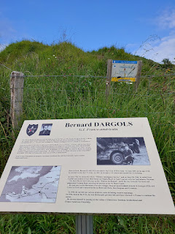

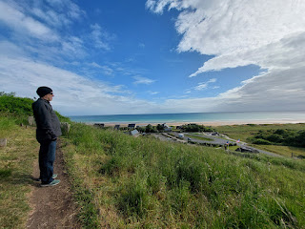

Video of Scott sharing his thoughts with me, as we stood above Omaha Beach: (43 seconds)

https://photos.app.goo.gl/mXvPz7u183fTg4CD7

Back down the hill and close to where we parked our car, there are some brand new memorials that were just placed this year.

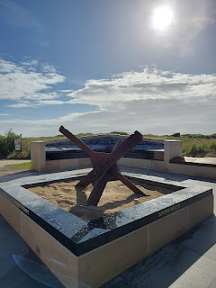

The signs explain in great detail the obstacles that needed to be overcome and how all of that was done. (click photos to enlarge)

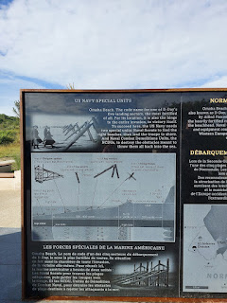

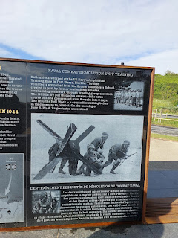

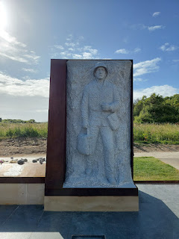

These men of the Naval Scouts and the Naval Combat Demolitions Units (NCDU's) were the beginnings of what would later become the Navy Seals.

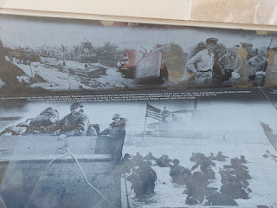

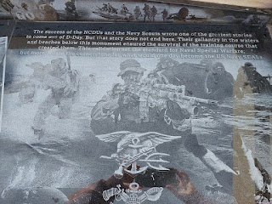

Video of one of the memorials, describing the grit of those young men: (14 seconds)

https://photos.app.goo.gl/iWNamTj2kucb7TrQ8

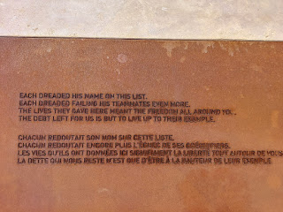

On the other side of these newly placed monuments and memorials, there was a path. It looked like it would lead us to the American Cemetery, so off we went.

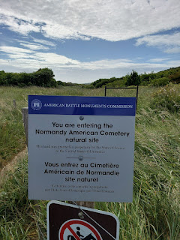

We walked for about 10-15 minutes, on a well-traveled path through fields and brush, before realizing that we would not be able to access the cemetery through this wilderness route. I could see an American flag high above us on the cliff, and I was pretty sure we wouldn't be scaling that cliff in order to get up there, ha ha. So we turned around and walked back to the car.

Before we drove to the cemetery, Scott wanted to see more of what was on the western end of Omaha Beach, so we drove all the way over there first. It wasn't far by car, maybe 5-6 minutes was all.

There was a single pier in the middle of the beach . . .

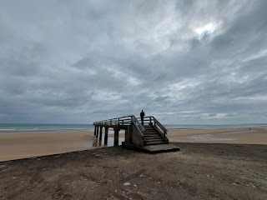

Video looking from Pointe du Hoc (to the west) over toward the rest of Omaha Beach (to the east): (15 seconds)

https://photos.app.goo.gl/otWFcxYrvP9RjdbZA

There wasn't a whole lot to see at the western end of Omaha Beach, but this bunker was pretty cool just sitting up on a hill.

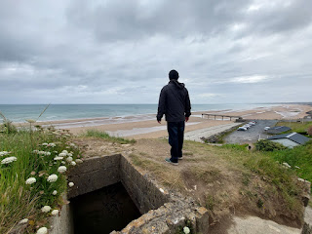

Per Wikipedia: During the Allied invasion of Normandy in June 1944, the artificial landing ports established at Arromanches, France were known as Mulberry harbors. These temporary portable harbors facilitated the rapid offloading of cargo onto beaches. The two Mulberry harbors, code-named Mulberry A (off Omaha Beach) and Mulberry B (off Gold Beach), allowed the Allies to receive reinforcements and supplies until major French ports could be captured and repaired. These innovative systems comprised floating breakwaters, pontoons, piers, and roadways. They played a crucial role in the success of the invasion.

Video as we drove past one of the bridges: (8 seconds) **WARNING: Turn your sound DOWN. It was super windy, which makes a very loud video.

https://photos.app.goo.gl/i9YP4sqmVTpTvQBCA

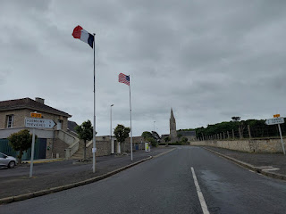

Next, we drove to the eastern end of Omaha Beach to visit the Normandy American Cemetery.

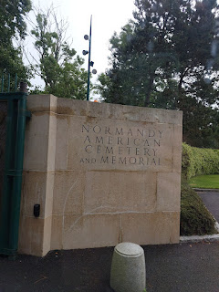

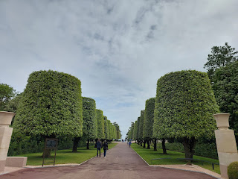

This sign explains a lot about the cemetery, including how and when it was formed. It encompasses 172.5 acres and is run by the U.S., on land that was granted by the people of France. (click photos below to enlarge)

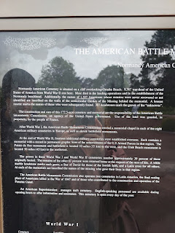

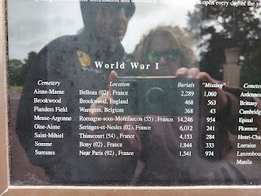

I was surprised to see the list of all the cemeteries around the world where U.S. servicemembers are buried, especially in Manila, Philippines. They had the most burials of any cemetery outside of the U.S. (*Sorry that the photo below is a little blurry because the camera was more focused on the photographer than on the words . . .)

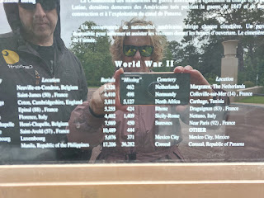

In warmer months, there is a large reflecting pool in front of where Scott is standing . . .

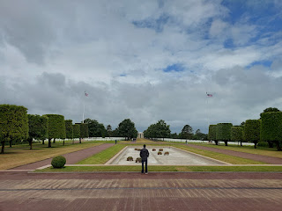

This memorial near the cemetery entrance was especially beautiful . . .

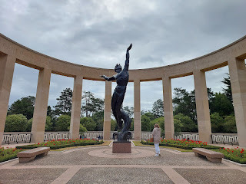

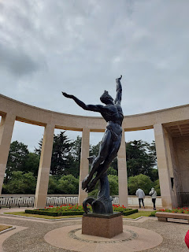

Video of the lyrics below the statue, going around in a circle: (18 seconds)

https://photos.app.goo.gl/FSJpca4BqMhaHfoC9

We walked slowly through the adjacent courtyard, with thousands of names inscribed on the memorial walls for those whose remains were never recovered. I felt it was important to look at each name, even though I was skimming . . .

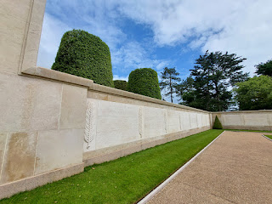

I tried to look for any surnames that might be related to our family, and a few names jumped out. The first one was John W. Cheshire, a 2nd Lieutenant in a bomb squad, particularly because he came from Florida. We have Cheshires in our family tree - they came from England and later immigrated to the U.S. They lived in South Carolina and Georgia in the 1800's and married into the Norman family, who were from Florida. It was interesting as I looked on my Ancestry Tree to see how they went from the spelling of Cheshire in England, and then later they changed it to Chesher when they lived in the southern U.S.

Also of note was a young soldier from Idaho,  listed directly underneath John Cheshire's name.

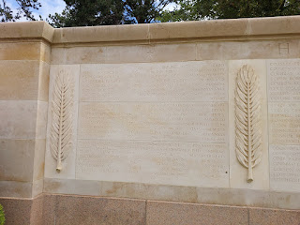

In this next photo, the name that jumped out to me was Samuel L. Murray (of CA). While it doesn't give a whole lot of information about him here, we have several Murrays from CA in our family tree.

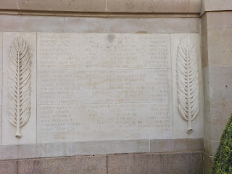

I found this link for Samuel Murray and his service during Operation Overlord:

Samuel L Murray : Private First Class from California, World War II Casualty (honorstates.org)

Lastly, the name Joseph F. Scheuermann Jr. jumped out at me, because the last name is so unique. I have a good friend in Ukiah, CA named Terry Scheuermann. I used to babysit for her kids when I was a teenager and we became really close during those years. I haven't seen her for a long, long time, but I plan to reach out to her to see if this servicemember might have been related to her husband, who I believe also had the name Joseph. What an amazing needle in the haystack that will be if they turn out to be related!!

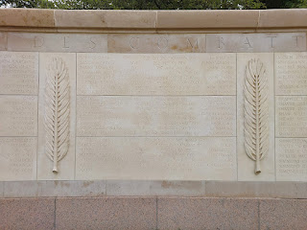

The white memorial crosses seemed to go on and on and on, further than any eyes could see.

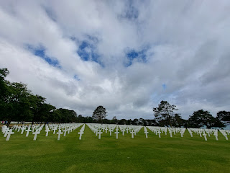

Video showing just a fraction of the American Cemetery on the cliffs above Omaha Beach: (18 seconds)

https://photos.app.goo.gl/r2nyQjShPWBCCQkG8

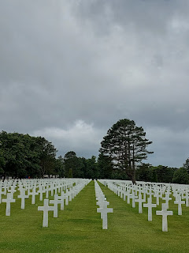

On the back of each marker, we could just make out the name, rank, what state they were from, and the day they died.

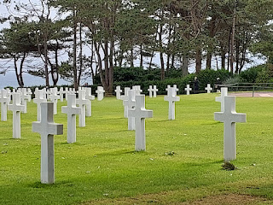

There is a little chapel further back in the cemetery, a quiet and peaceful place to pause and reflect. The mosaic on the ceiling really took my breath away. We don't often think about the possibility of angels being in the midst of a battle or on the front lines. But please take a moment to examine this scene and see what your heart says to you . . .

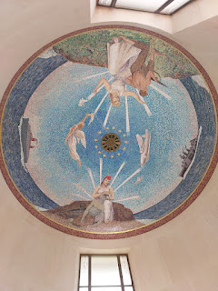

In the chapel, there was a sign that says: "The flame burning before you was collected May 8, 2024 in Paris, from the tomb of the unknown soldier located under the Arc de Triomphe. This flame was deposited here on May 13, 2024. This is the flame of the French Nation, escorted from Paris by 34 young French people who, on behalf of all French citizens, bring their gratitude and deep appreciation to the American people for their immeasurable commitment during Operation Overlord on June 6, 1944.

"This flame will remain lit until June 6, 2024. Right here, 80 years ago, thousands of soldiers defied adversity, braving the waves and enemy fire to break through the Atlantic Wall, which was thought to be impassable. This flame burns today in their honour, reminding us of their courage and determination to defend the values that unite us today. It reminds us that peace is precious, and that the Freedom in which we live must be protected at all costs."

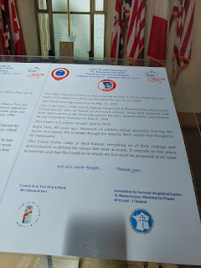

While the flame was already extinguished by the time we got there, the lantern was still there, along with the powerful words and tribute.

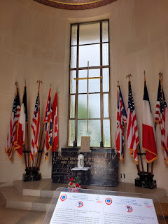

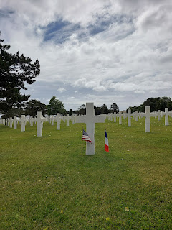

We saw an occasional Jewish memorial marker. I was drawn to them, not only because of their simple beauty, but because of my current study and research of my Bassano family and their ties to Judaism.

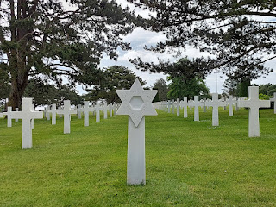

This was a peaceful place to organize a cemetery, overlooking the beach below where so much happened 80 years ago, both good and bad.

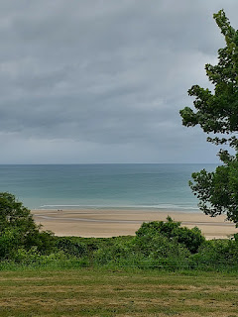

As we began walking back to the car, I saw a couple trying to take a selfie of themselves. I offered to take a photo of them, which they gratefully accepted. We chatted with them a bit - because they were from the U.S. too, and we found the most amazing connection. They are very good friends with the Wilsons in our Vicenza Ward back in Italy and have crossed paths in their military service around the world. They were surprised to hear that Chance Wilson was just put in as our new Bishop a couple weeks ago, and told us that several years ago Chance was their Branch President when they lived in Vicenza at that time. What a small world!! I can't believe we ran into them, out of all the people in the Normandy region that day . . .

(*Note: In the Church of Jesus Christ of Latter-day Saints, a smaller congregation is referred to as a Branch and will have a Branch President assigned to lead them. A larger congregation is referred to as a Ward, with a Bishop assigned to lead them.)

Janet and Brent, and the two of us . . .

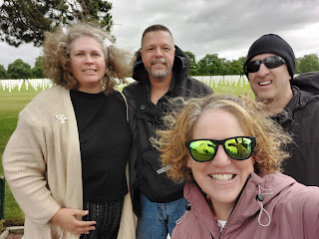

Video showing one of the tiny towns between Omaha Beach and Gold Beach: (14 seconds) It still looks like it did in all of the black & white photos that we see today from WWII.

https://photos.app.goo.gl/3NnbKDVLkD2UASh39

We made a super quick stop to see an unexpected memorial area next to the road on our way to a scheduled beach activity. I'm glad we took a couple of minutes to see what was there, including this sweet tribute to the elderly veterans of World War II.

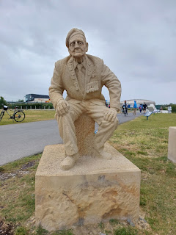

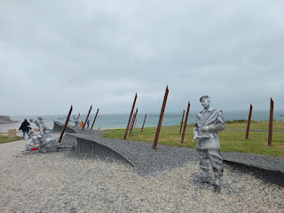

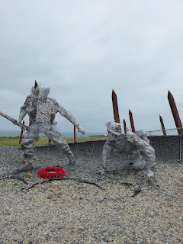

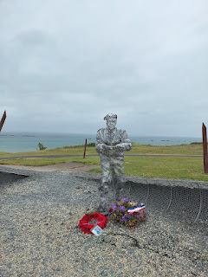

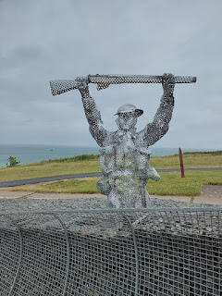

This memorial area overlooks Gold Beach and is the location of several artificial harbors that still survive out in the water. In the photo below, you can see the little hut in the foreground that says, "1944 Mulberry B". Gold Beach is next to Arromanches-les-Bains, which is where this memorial "cliff" is located. They also had a museum and a cinema experience, but we were in a hurry to get to our appointment so we did not take advantage of those extras.

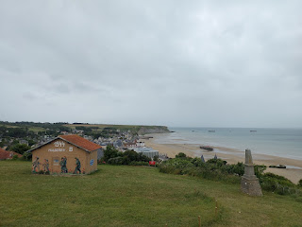

Here and there, throughout the Normandy region, there is a section of these WWII bridges sitting next to the road or next to a museum.

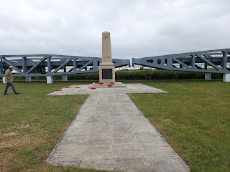

This photo shows how they were used 80 years ago, on top of the artificial harbors known as Mulberry A or Mulberry B.

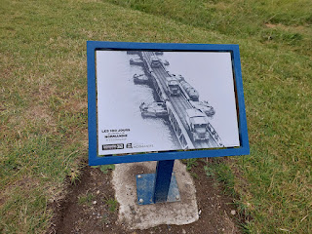

The activity that we had originally signed up for was to kayak out to the Mulberry harbors off Gold Beach.

Sadly

(and I do mean devastatingly sad), the weather was not conducive for kayaking at all. With off and on rain along with 20-30 mph winds, we had to choose their back-up activity, which was called "Sand-yachting" or "Land-sailing".

Scott and me in our matching neoprene wetsuits . . . (*Note: you can see the artificial harbors in the ocean behind us in the photos and videos)

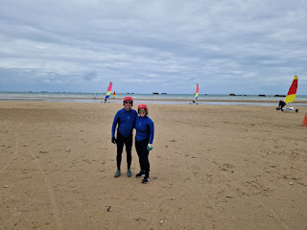

Our guide, Valentin, showed us how to run the contraption, which is something like a go-cart with a sail attached to it. Your feet control the steering by pushing the lever on the right to turn right, or on the left to turn left. Your hands are holding onto a rope, part of a pulley system, to control your speed. You have to "pump" the rope to get things going.

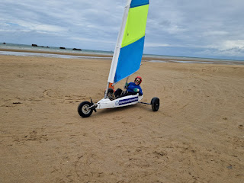

I had the one with a blue and neon-yellow sail, while Scott's was red and yellow.

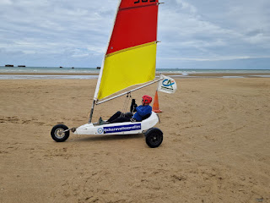

Here is a link to a video that closely resembles our experience: (3 min, 18 seconds)

https://youtu.be/79EfR-PA83k

Here's one more video that has some great instruction for land sailing, starting around 3 minutes in: (5 min, 20 seconds)

https://www.youtube.com/watch?v=lx2TN35RWxg

Video #1 of us land sailing: (27 seconds)

https://photos.app.goo.gl/LSigdsezbsR2Gv8D9

Video #2 of us land sailing: (32 seconds)

https://photos.app.goo.gl/Euc7PSJbjPEnUynB8

Video #3 shows Valentin riding on the "train" of carts heading back to their shop from the beach:

(11 seconds)

https://photos.app.goo.gl/6FEMMHgdbBUShpBC9

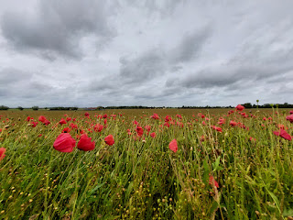

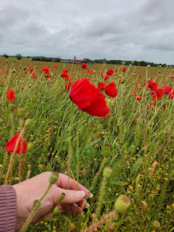

Video of a beautiful field - full of lavender wildflowers on the way to Utah Beach: (8 seconds)

https://photos.app.goo.gl/4TqiRi7KgePspVku6

Video as we passed through a small town, called St. Marie du Mont, near Utah Beach: (38 seconds)

https://photos.app.goo.gl/cNvfnUiiwbQSjVQg9

Just imagine that town with soldiers marching through or driving their Jeeps through in 1944. Wow.

The WWII Museum at Utah Beach . . .

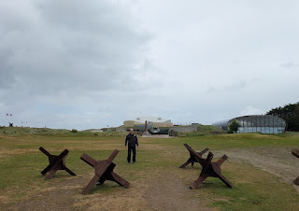

This was the only D-Day Museum that we actually got to visit. Because we spent so much time on the beach, we ran out of time to spend at the Omaha Beach Museum, which is more extensive I think, and then we arrived just a hair too late at the D-Day Experience Museum and they wouldn't let us in. We just needed more time in Normandy and then we could have seen and experienced a lot more.

We watched a film in the little theater within the museum, which was really moving. They showed us how the engineer battalions pushed their way onto Utah Beach, with much less casualties than Omaha Beach, and how they established roads and supply chains to head inland so quickly. They were able to not only get weapons, food, and medical supplies inland, but they were also able to transport injured soldiers back out to the ships. It was immensely impressive to see how they accomplished their very singular goals and how it allowed everyone else on the other beaches to have more success with their own missions.

Everyone had a job, and no job was insignificant.

In this museum, I really enjoyed getting "up close and personal" with D-Day and the people that contributed to its success. I read a lot of information and I really connected with the memorabilia that was on display throughout.

This next photo talks about something we probably haven't thought about or even knew about. The French were really oppressed because of the Nazis that took over their country. They were hungry, poor, and inflation was skyrocketing, making everything even more difficult. When the U.S. arrived on the scene and helped to free their towns and villages, they acknowledged it as a massive rescue and they are still so, so grateful all these years later. (click to read more in the photo below)

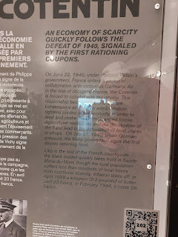

The French quietly organized their own Resistance, and at the same time the government put together a military draft. In the next photo, a young French man named Jules Fafin, received his draft order by a postcard in the mail. He fought for freedom in France, later becoming a POW before being freed himself. He received a medal for his efforts.

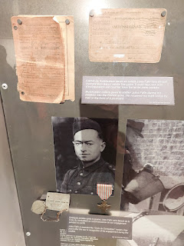

Below: an official resistance card that was sent to Michel LeLarge for his efforts during the war. The card was sent to not only recognize his contributions, but to say thank you.

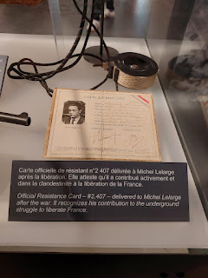

The French Resistance rigged homemade radios so they could listen to the BBC News, which often sent coded messages to them in their broadcasts. You can read more in the photo below - click to enlarge.

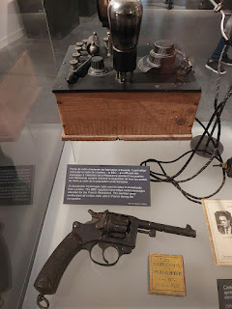

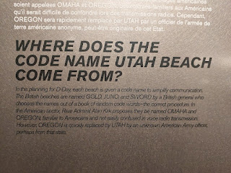

This flag accompanied Rear Admiral Don Moon throughout his missions across Europe during WWII.

He was born in Indiana in 1894 and joined the Navy, graduating 4th in his class from the Naval Academy. His expertise was in gunnery. He was in charge of the whole mission to conquer Utah Beach on D-Day and in the weeks to follow. Sadly, he succombed to what is known as battle fatigue, and he shot himself and died on August 5, 1944 after the major operation was over in Normandy. He was buried in Arlington Cemetery, leaving behind a wife and four children.

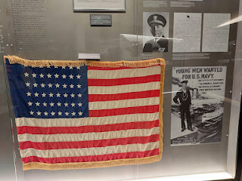

For 6 months, James E. Arnold "kept a diary in which he recounted his work as a Naval officer in charge of Utah Beach, then in the port of Le Havre, as well as his reconnaissance missions in Cherbourg, Rennes, Nantes, and Saint Malo. He also recounts his interviews with Theodore Roosevelt Jr., Winston Churchill, and General de Gaulle. Written in a German accounting book found in a bunker at Utah Beach, this account is illustrated with photographs, newspaper clippings and drawings."

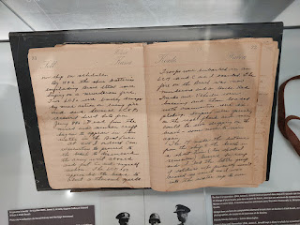

He is in this photo below . . .

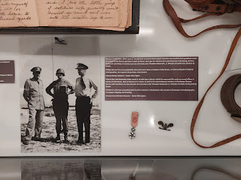

Flag flown on the USS Tuscaloosa on D-Day . . .

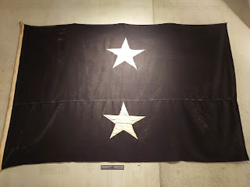

A tank named "Ethel" . . . LOL

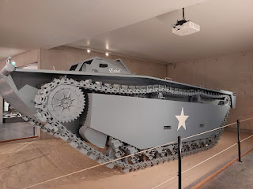

The USS Rich was sunk off the coast of Utah Beach on 8 June 1944. For an edge-of-your-seat reading experience, check out what happened here:

https://en.wikipedia.org/wiki/USS_Rich_(DE-695)

Scroll down to the sections "WWII" and "Sinking".

This was a coffee pot found in the wreckage of the USS Rich . . .

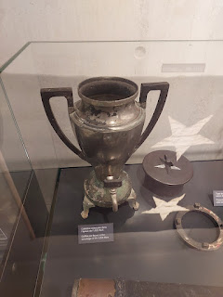

Explanation in the photo below: "In June 1944, Louise Ross became a volunteer radio operator in Iowa. She wrote to her fiance, Stewart Kaufmann, also a radio operator, aboard the destroyer USS Rich. In her letter . . . . (unreadable) . . . life as a young couple. Eight weeks later, Stewart Kaufmann disappeared in the explosion of the USS Rich, which was hit by three submarine mines, off Utah Beach on June 8, 1944. The letter was found in the wreckage of the ship, which was raised in the 1950s. Stewart Kaufmann's name is inscribed on the Wall of the Missing at the Omaha Beach American War Cemetery."

See if you can piece together what Louise wrote to Stewart in the letter below . . .

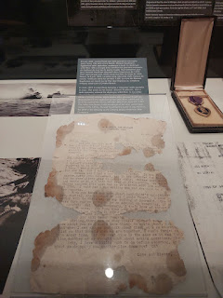

One of the troop transports that came ashore on D-Day . . .

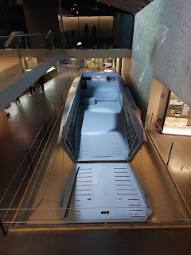

A large room that showed some of the obstacles that soldiers had to overcome by whatever means necessary in order to get to land, to safety, and to fulfill their missions.

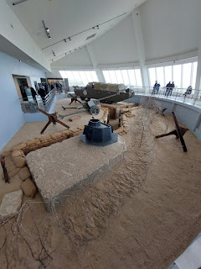

It was pouring "cats and dogs" outside while we wandered through the museum. I managed to get a decent photo through the rain-soaked window, looking out at some of those same obstacles that the Germans had rigged to slow their foes down.

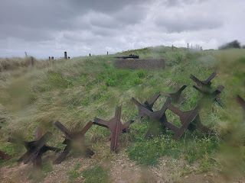

"Emergency high-protein chocolate bars. Very bitter in taste, these "D-rations" were so dense that it took significant effort to eat them. Universally disliked, soldiers often discarded them."

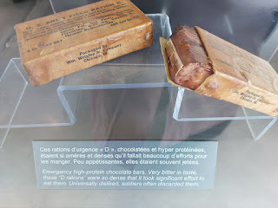

Take a closer look at this next photo, particularly the little whistle-shaped object in the center. Then you can read the explanation below the "cricket".

We watched a video clip of a WWII veteran explaining how vital these little "crickets" were in the cloak of darkness and in unfamiliar territory.

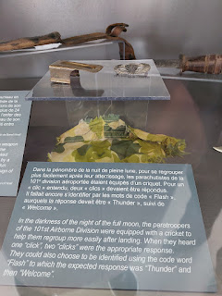

Here's a link to a really interesting article about the "clickers":

https://www.americanheritage.com/original-cricket-clicker-found-75th-anniversary-d-day

An old army Jeep from the D-Day landings near Utah Beach . . .

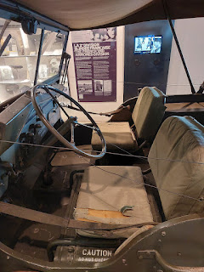

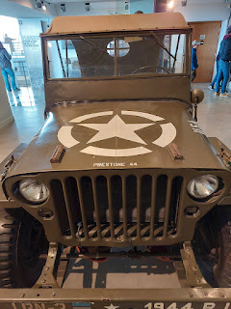

Dresses made from various American parachutes . . . (more info below)

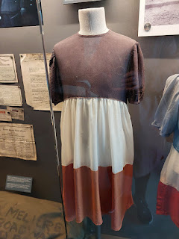

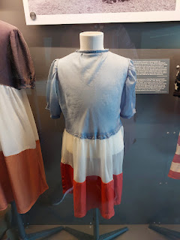

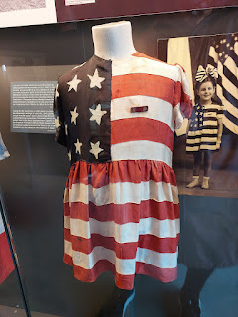

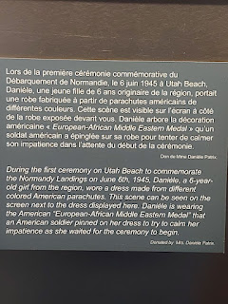

In the upper left corner below, it says: "Honor Guards of the 1st Engineer Special Brigade watch over the monument. Four young French girls wear dresses made of parachute canvas symbolizing the two nations. At the close of the ceremony, both flags are handed to the care of the town. They are now displayed in the crypt underneath the monument."

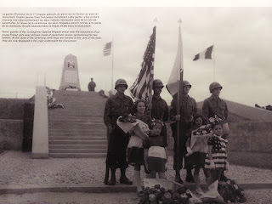

An explanation of 45 memorial plaques that Colonel Eugene M. Caffey designed to honor the men that he lost in his brigade, the 1st Special Engineer Brigade. (click photo below to read about his motivation to do this)

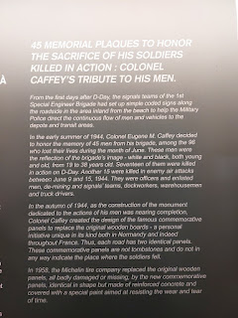

More information about a couple of the signs that he had placed: (click photo to enlarge)

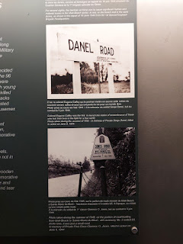

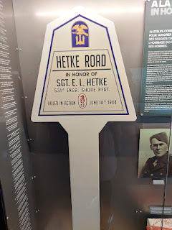

The rain had stopped - temporarily - as we headed outside. We had a few short minutes before the skies began dumping their next round, ha ha.

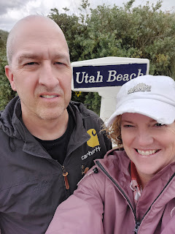

Video of a poignant phrase on a fence full of locks - "Remember": (6 seconds)

https://photos.app.goo.gl/sVip36mpFMW8g4C36

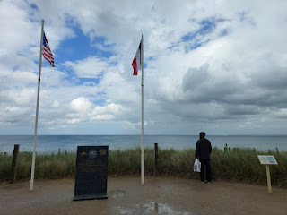

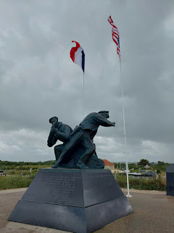

Video showing, yet again, evidence of the love that France has for the U.S.: (6 seconds)

https://photos.app.goo.gl/WkeAmAW1X99Xs1cY7

Views looking out at Utah Beach from behind the museum . . .

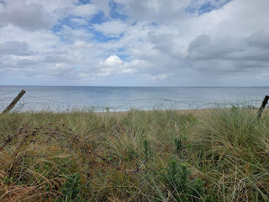

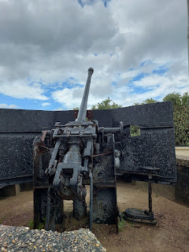

I couldn't help but take a short video of us running as fast as we could back to where we parked our car. It had been pouring mercilessly earlier. After a short break, and just as we were trying to leave, the skies opened up once again.

A human moment. LOL

(3 seconds)

https://photos.app.goo.gl/RYFGwmS8Ka8LdDEU7

On our way to a special place, Scott was kind enough to pull over so I could say "Bonjour" to these beautiful horses. I think they were a little surprised when I walked up to their gate, and if I had had an apple with me, I bet they would have been more willing to "chat".

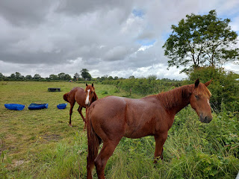

My good friend, Steve Meyers, a fellow genealogist from Idaho Falls, is currently serving a Military Relations Mission in North Carolina with his second wife, Julia. (His first wife, Trish, died a couple years ago after open-heart surgery.) They are serving on a base that used to be called Fort Bragg, but is now renamed Fort Liberty. He wrote me recently about a church in Normandy where a 101st Airborne paratrooper got hung up on the church steeple during a landing gone awry. To this day, they have a "dummy" paratrooper hanging from the church to honor him.

I decided to look into the story to see where the church was in relation to the other places we would be visiting in Normandy. I was elated to see that it was close by and that we would be able to squeeze it in, and then I could share some photos and videos with Steve and Julia afterwards.

Video coming into Sainte Mere Eglise, France: (23 seconds)

https://photos.app.goo.gl/VG1QJwWZyyznnqko7

The paratrooper: John Steele

The date: 5-6 June 1944

The location: Sainte Mere Eglise, France

Essentially, there were a few things that went wrong during the massive Operation Overlord, as was to be expected. One of those things was that the planes set to drop some of the paratroopers were off course, and they ended up dropping them up to 10 km away from the intended drop zones. Another issue that no one could have predicted is that there was a fire in Sainte Mere Eglise that night, with several French locals and German soldiers working hard to put the fire out. As the paratroopers began to descend - way off course - they were also unintentionally illuminated in the night sky by the flames of that darn fire in the center of town. Now everyone could see them coming in to land . . .

There are more details than what I have time to type up, but you can read this very direct blog to get the full story. I say "direct" because the author of the blog post mentions John Steele's military nickname right off the bat . . . you'll see. The author also likes a lot of run-on sentences, ha ha. But there are some great details to understand. John Steele's story is included in the movie "The Longest Day", filmed in 1962 with Red Buttons playing the part of John Steele.

https://www.normandyamericanheroes.com/blog/sainte-m%C3%A9re-eglise-paratrooper-john-steele

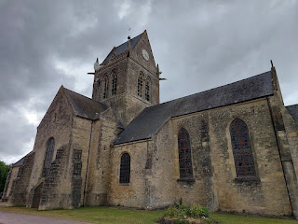

Video of the steeple and the "dummy" paratrooper: (7 seconds)

https://photos.app.goo.gl/NdtHgEd67Xy2J5uV8

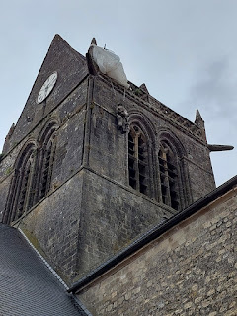

The thing that makes this church so special, is that not only is it centuries-old (11th century), but they also continuously commemorate John Steele by keeping a fake, or "dummy" hanging on the steeple all these years after the event happened. They want to preserve the story and the sacrifice of so many who came to free their town, which was one of the first towns to be freed from the Nazis after D-Day.

There is even a John Steele Restaurant just up the street from the church, and he came back to visit the town numerous times before he passed away in 1969.

Video entering the church: (6 seconds)

https://photos.app.goo.gl/4fWFCucNamKBYfbi6

Inside the church, there are a couple of interesting stained-glass windows. (click photos to enlarge)

Some might say the scenes on the stained glass are sacrilegious, while others may say that religion still exists in the midst of a war. You can be your own judge.

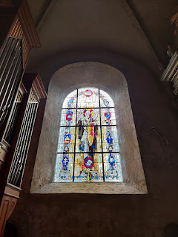

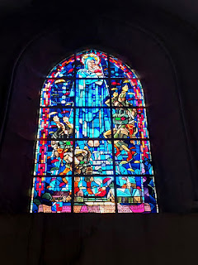

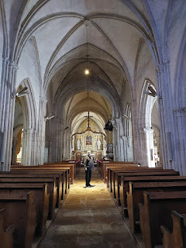

Video with a 360-degree view of the church square: (20 seconds)

https://photos.app.goo.gl/4CGBaQ5Cva3tbGXu9

In the courtyard surrounding the famous church, there are several info markers that I enjoyed reading. (click each one to enlarge)

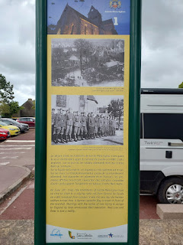

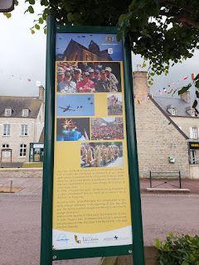

From the main square next to the church, looking up the main street . . .

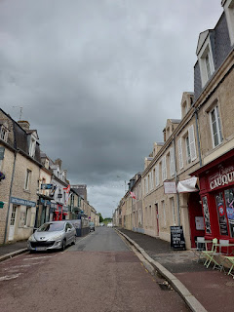

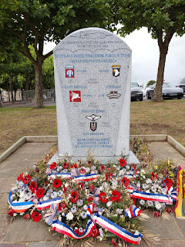

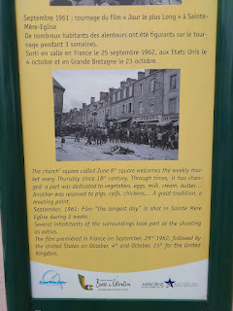

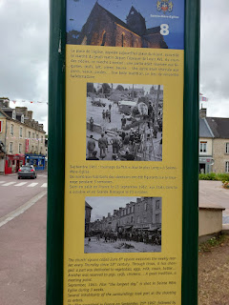

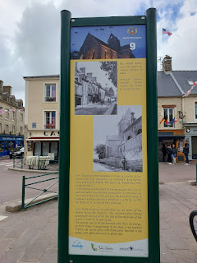

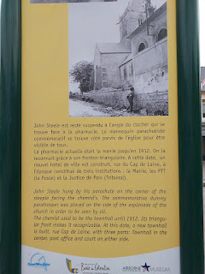

We decided to go check out the John Steele Restaurant for dinner. It was really cute inside and the meal was served promptly.

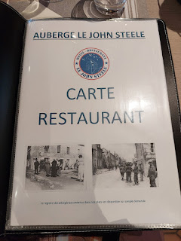

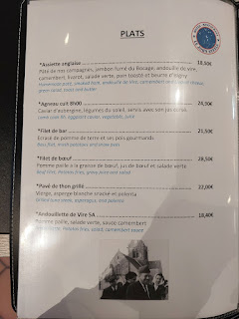

We ordered the Burrata Salad, which consisted of: tomatoes, pine nuts, a hint of pesto, olive oil, and a nice big dollop of burrata, which is a creamier version of fresh mozzarella. I really love burrata. And this salad was amazing! Everything was so fresh and so flavorful. I want to try to recreate it at home soon.



The main course was bass fillet, mashed potatoes and snow peas. They tasted great, although the bass fillet was a little plain.

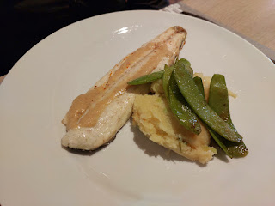

Beautiful red/white/blue flowers outside the restaurant . . .

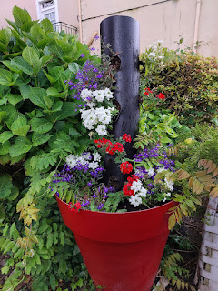

Sunday, Father's Day: June 16th

We drove to the nearest church building, which was about 30 minutes east of the farm where we were staying. It was in the city of Caen, France. Wanna know something crazy? Caen is pronounced like "kong" but without the "g" at the end. Try to add in a lot of spit from the back of your throat as you say it, too. LOL

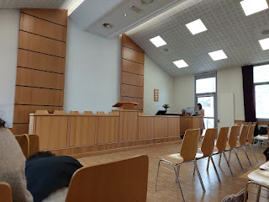

I have only sung hymns in French one other time, and that was in Rouen, France back in 2018. I'll tell you what, singing in another language is super helpful, especially when you are in a room filled with people who know and speak the language. As you see the written words at the same time as you hear a congregation pronouncing them, it really helps you figure a few things out!

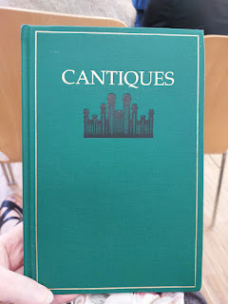

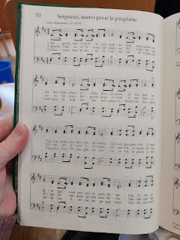

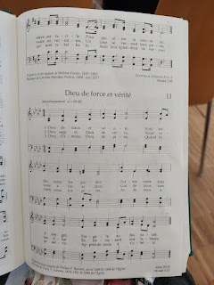

Video of the Sacrament hymn: (32 seconds)

https://photos.app.goo.gl/DKg5N9CpogBC9ebA7

Video of the "rest" hymn - or middle of the meeting - hymn: (54 seconds)

https://photos.app.goo.gl/7Kc4bJsZbYEe81uF8

Video of the closing hymn: (36 seconds)

https://photos.app.goo.gl/Litrv5HYjbsrvMxx9

We each had a translator with headphones to listen to during the meeting, with a lady speaking quietly into a microphone in English for us. Scott used his Google Translate app again, and this time it worked really well. In the German ward up that we attended in Northern Italy last fall, it didn't work very well. But this time, I would look over to see what his phone was saying and it was often better than what the lady was doing!

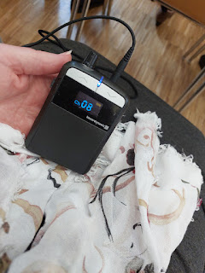

Video of the primary children singing a couple of songs on Father's Day: (2 minutes, 36 seconds)

https://photos.app.goo.gl/noE8uG8JYTKpwBkY6

Video of them singing, "Love One Another": (43 seconds)

https://photos.app.goo.gl/9HZzkpDxcpxgnUmG9

Scott, outside the church door before we left . . .

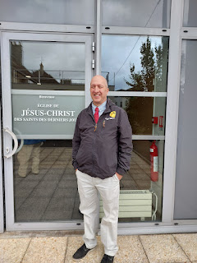

After church, we drove over to see Mont St. Michel - a gorgeous 1,000 year old Abbey. I will write about that in another blog post, since this one is just focused on Normandy.

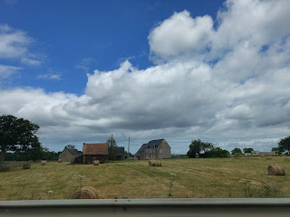

After Mont St. Michel, we stopped by the D-Day Experience Museum, but we were too late. They weren't admitting any more guests that evening and were already closing everything down. So we just wandered around outside to see what we could see.

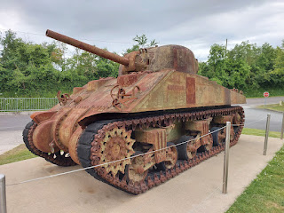

This is one of the many types of barricades that the Germans rigged to get in the way of the Allies coming onto the beaches. Scott is standing behind it . . . all symbolic-like, ha ha.

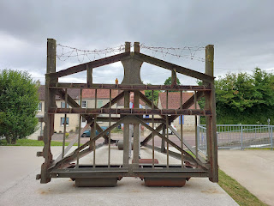

Behind the museum was a big deal called Dead Man's Corner. We had no idea what it was all about. Wow. Pretty incredible, actually. (click photos to read)

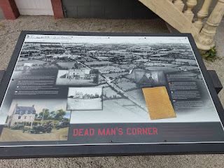

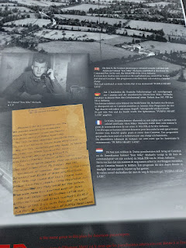

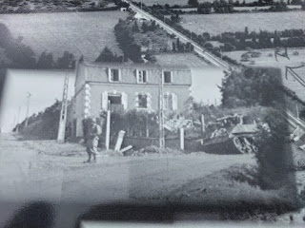

This museum was also closed . . .

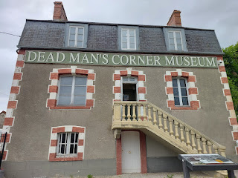

But a tank was on display at the corner of the intersection . . .

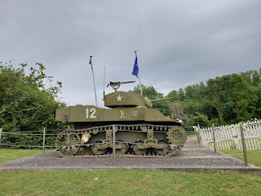

After a careful inspection, Scott was pretty confident that this gun was one of ours, and not German.

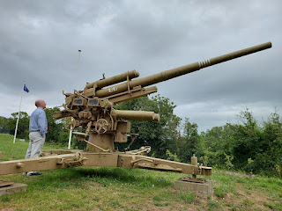

On our last morning in Normandy, we drove to the eastern-most end of Omaha Beach to try to find something that I had stumbled upon in Google Maps. It was known as WN 60, a stretch of German bunkers high on the bluff above the beach. We decided to hike up there first thing after breakfast and after we checked out of our room at the farm.

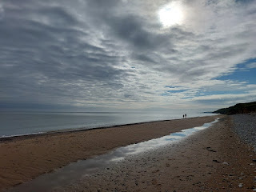

Come and take a walk with me down Omaha Beach: (17 seconds)

https://photos.app.goo.gl/fV8f9PWSf1P1cQtG8

We followed what was on Google maps and it eventually led us away from the beach, where we had to scurry like mountain goats up onto a path that led into the brush.

Picture a much different scene 80 years ago, one that was a lot more scary in the silence of the trees on this path . . . today, there are birds chirping and a very relaxing silence. But during war time, your senses would have been heightened and the hair might have raised up on the back of your neck as you crept slowly and quietly down this lane.

Video of this very scene: (20 seconds)

https://photos.app.goo.gl/KeavFABKh68KuhPW9

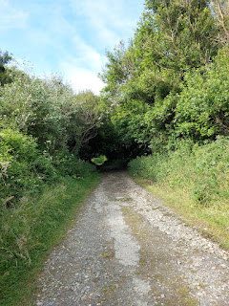

After another goat-like effort to shimmy up a tiny little path, we made it up to the grassy meadows that overlook Omaha Beach. There are several old bunkers up there, with the original trenches that run from one to the next and the next.

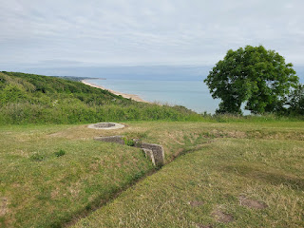

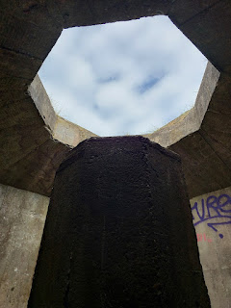

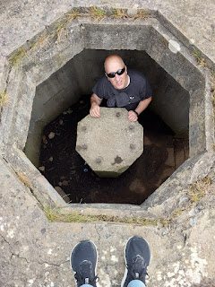

It was quiet up there, and apparently we were the only ones brave enough to trek up to see this historical site. Scott mused for a few minutes about how everything would have gone down on D-Day from this vantage point. And then we made our way back down.

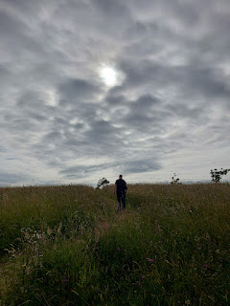

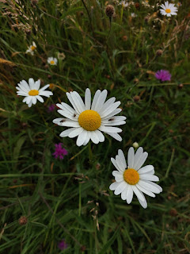

On this particular day, groups of high school students were getting a chance to experience Omaha Beach by getting in the water. There were instructors and guides setting them up for paddle-boarding and kayaking as we walked back to our car.

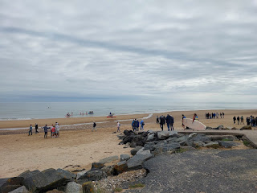

I saw these as we drove toward our last activity in Normandy, and once again, Scott was kind enough to pull over so I could get some pictures. They were just so lovely.

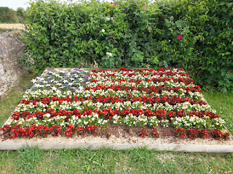

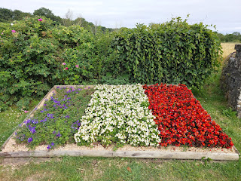

Right next to the floral flags, stood a church with a huge poster in front of it. Click to enlarge the photo and see what happened to this church during the War, and how it has since been re-built.

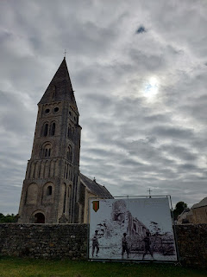

Our last big hurrah was to ride some horses. I was so excited for this adventure! Our guide didn't speak more than just a few words in English, but we somehow did just fine.

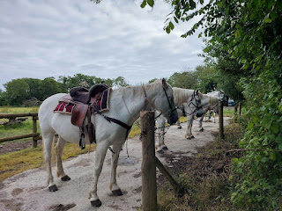

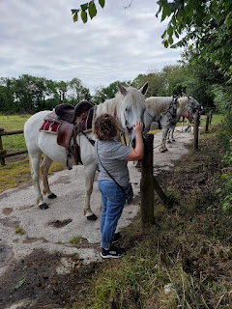

Everyone else rode on a beautiful white horse . . .

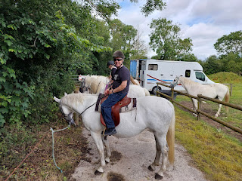

I ended up on a brown horse named Bundy. He was quite a character. I don't think he paid much attention to where he was walking, because more times than I could count, he'd trip up somehow, or one of his feet would end up in a hole in the ground, causing him to startle. Thankfully, I've been on horses enough times to be confident. But he was a piece of work, ha ha.

We rode through a tiny little village . . .

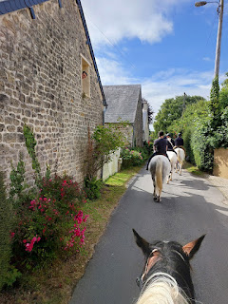

and into the forest . . .

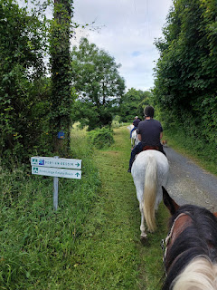

Video on the forested path as we passed old homes nearby. The town was on our left and Omaha Beach was on our right, over the ridge. (17 seconds)

https://photos.app.goo.gl/knt1SVghoc1huNmN9

On our way toward Omaha Beach . . .

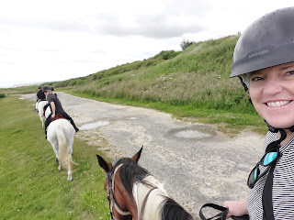

Me and Scott, when the horses were allowed to stop for a snack . . .

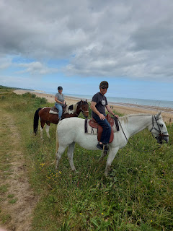

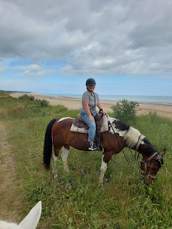

There was one other couple on our trail ride, both of whom were French.

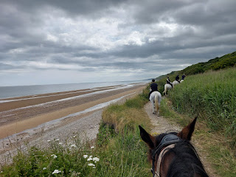

Video of one of the times Bundy stumbled, bless his little distracted heart: (7 seconds)

https://photos.app.goo.gl/iMphKep71MgpQMPR9

Video as we turned onto the same area of the beach where the kids were paddle-boarding earlier:

(7 seconds)

https://photos.app.goo.gl/PTuXrurxHeihn8537

Scott and his horse on one final snack break . . .

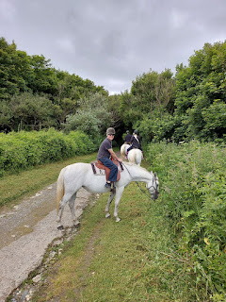

At one point, we had to navigate a not-too-steep but still a downhill incline. My horse buckled for a moment, tripping somehow again, and I thought for sure I was either gonna get launched or that he might end up on top of me . . . but he recovered quickly and we continued on. The guide came back to inspect the horse briefly, making sure he was okay and not injured in the tumble, but he was fine. I was a little rattled, since I've never had anything like that happen to me before, but I'm just glad it all ended up alright.

It was a lovely and relaxing ride, except for the times when Bundy would inadvertently trip.

I would highly recommend a variety of ways to experience the Beaches of Normandy. It's one thing to see it with your eyeballs, and to read the signs and try to absorb all of the information. But it's a whole different experience if you can get in the water, or do an activity on the beach, or ride a horse along the beach. Using more of your senses will help you to connect to where you are and will be extremely memorable in the years to come.

This was an experience I will NEVER forget. It was a dream come true. It was a story that came to life for me. It was a pilgrimage of epic proportions. And it was a way to honor those who fought and gave their lives here in order to secure freedom and prosperity for all the rest of us, who many times take it all for granted.